NAME:T.CHANDRA LEKHA
REG NUMBER:192472290
COURSE CODE:CSA0910
COURSE NAME:PROGRAMMING IN JAVA

1.Single Inheritance – Scenario Scenario:
A company has a Vehicle class with methods startEngine() and stopEngine(). A Car class extends Vehicle and adds a playMusic() method. The company now wants every car to automatically log the engine start time whenever startEngine() is called, while still using the original engine-start functionality

Class Diagram
Vehicle
|
|
Car
Q1. How would you implement this using single inheritance?
Create a parent class Vehicle containing startEngine() and stopEngine(). Then create a child class Car that extends Vehicle.
class Vehicle {
void startEngine() {
System.out.println("Engine Started");
}

void stopEngine() {
System.out.println("Engine Stopped");
}
}
class Car extends Vehicle {
void playMusic() {
System.out.println("Playing Music");
}
}
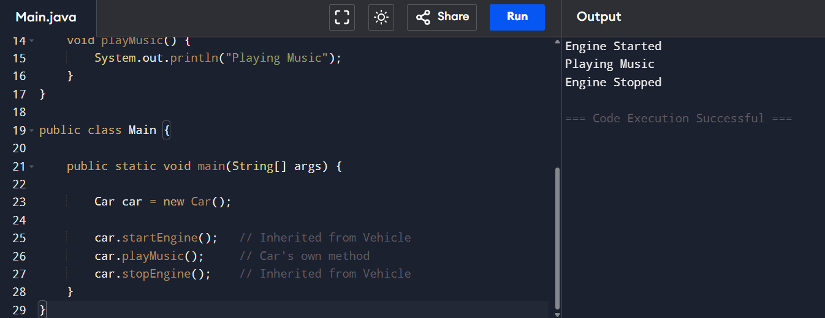

Explanation:
- Vehicle is the parent class.
- Car is the child class.
- Car automatically inherits startEngine() and stopEngine().
- Car also has its own method playMusic().

Question 2: Should Car override startEngine()? Why?

Answer
Yes.
- The Car class should override the startEngine() method because the company requires every car to log the engine start time whenever the engine starts.
- By overriding the method, the child class can add extra functionality while still performing the original engine-start operation.

Example

class Car extends Vehicle {

@Override

void startEngine() {

super.startEngine();

System.out.println("Engine Started at : "

+ java.time.LocalTime.now());

}

}
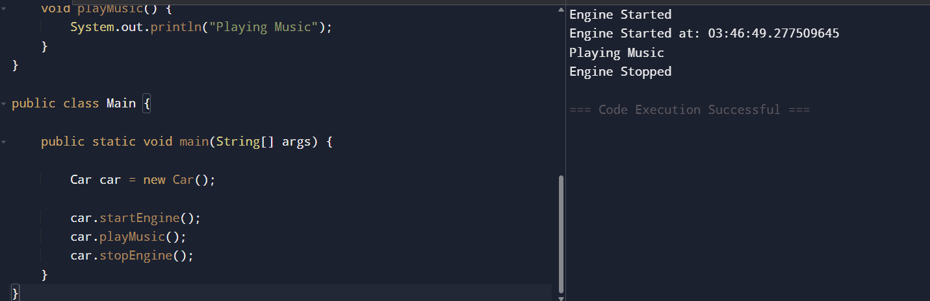
Explanation:
- The engine starts normally.
- The current time is then displayed.
- The original functionality is preserved
Question 3: How can the parent class implementation still be executed?

Answer
- The parent class method can be executed using the super keyword.
super.startEngine();

Explanation:
- super refers to the immediate parent class.
- It executes the original Vehicle implementation before executing the additional code written inside Car.
Question 4: What happens if Car does not override startEngine()?
Answer
If Car does not override startEngine():
- The method is inherited directly from Vehicle.
- The engine starts successfully.
- The engine start time is not logged, because no additional functionality is added.

2. Multilevel Inheritance – Scenario Scenario:
A software company models employees as follows:
•Employee → stores employee ID and name.
•Developer extends Employee → stores programming language.
•SeniorDeveloper extends Developer → stores team size and performs code reviews.
Now HR requests that every SeniorDeveloper should be able to access employee information and programming language details without duplicating code. Questions:

Class Diagram
Employee
|
Developer
|
SeniorDeveloper
Q1. Why is multilevel inheritance suitable here?
Because each class adds new features while inheriting the previous ones.
- Employee → Employee ID, Name
- Developer → Programming Language
- SeniorDeveloper → Team Size, Code Reviews
This avoids duplicate code and improves reusability.

Q2. Which members are accessible in SeniorDeveloper?
SeniorDeveloper inherits all accessible members from both parent classes.
From Employee
- Employee ID
- Name
- Employee methods
From Developer
- Programming Language
- Developer methods
Own members
- Team Size
- Code Review methods

Q3. If Developer overrides a method from Employee, which implementation will SeniorDeveloper inherit?
- SeniorDeveloper inherits the Developer's overridden version.
Example:
class Employee {
void display() {
System.out.println("Employee Details");
}
}
class Developer extends Employee {
@Override
void display() {
System.out.println("Developer Details");
}
}
class SeniorDeveloper extends Developer {
void codeReview() {
System.out.println("Performing Code Review");
}
}
public class Main {
public static void main(String[] args) {
SeniorDeveloper sd = new SeniorDeveloper();

sd.display();
sd.codeReview();
}
}
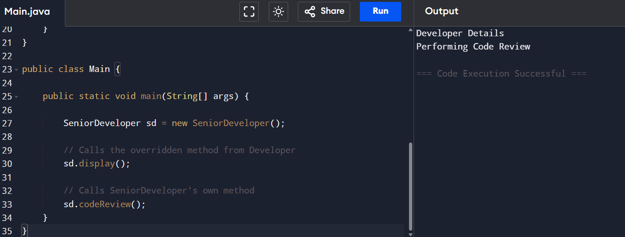

Question 4: Draw the inheritance hierarchy.
Employee
│
Developer
│
SeniorDeveloper

3. Hierarchical Inheritance – Scenario Scenario:
An online shopping application has a base class Payment. Three classes inherit from it:
•CreditCardPayment
•UPIPayment
•NetBankingPayment Each payment type processes transactions differently but shares common validation logic.
Q1. Why is hierarchical inheritance appropriate here?
Because multiple classes share the same parent but implement different behaviors.
All payment methods require:
- Validation
- Payment ID
- Amount
But transaction processing differs.

Q2. Where should common validation logic be implemented?
Inside the Payment class.
Example:
class Payment {

void validate() {
System.out.println("Payment Validated");
}
}
Q3. How can each payment class provide its own transaction processing?
Each child class overrides processPayment().
class CreditCardPayment extends Payment {
void processPayment() {
System.out.println("Processing Credit Card Payment");
}
}
class UPIPayment extends Payment {
void processPayment() {
System.out.println("Processing UPI Payment");
}
}
class NetBankingPayment extends Payment {
void processPayment() {
System.out.println("Processing Net Banking Payment");
}
}
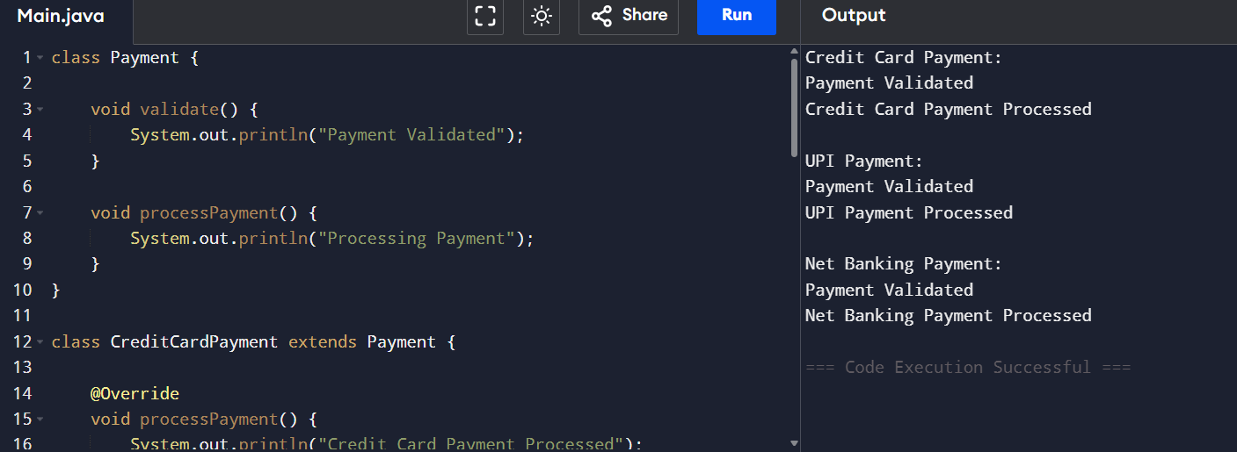

Question 4: What is the advantage over writing three independent classes?
Answer
Advantages include:
- Code reuse
- Reduced duplication
- Easy maintenance
- Better scalability
- Easier future updates
For example, if validation logic changes, it only needs to be updated in the Payment class instead of all three child classes.
4. Compile-Time Polymorphism (Method Overloading) –
Scenario Scenario: A calculator application supports addition of: •Two integers •Three integers •Two decimal numbers The product owner wants users to call the same method name (add) regardless of the input.
Scenario
A calculator supports addition of:
- Two integers
- Three integers
- Two decimal numbers
The same method name (add) should be used for all operations.
Question 1: Which OOP concept should be used?
Answer
The appropriate concept is Method Overloading (Compile-Time Polymorphism).
Example

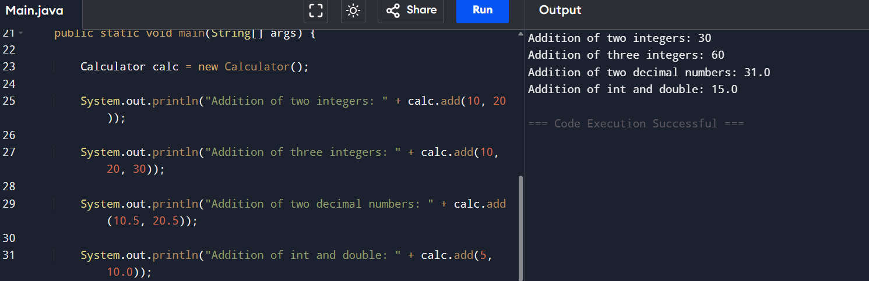

Question 2: How will Java decide which method to invoke?
Answer
Java selects the appropriate overloaded method during compile time based on:
- Number of parameters
- Data types of parameters
- Order of parameters

Question 3: Can methods be overloaded by changing only the return type?
Answer
No.
Methods cannot be overloaded by changing only the return type because Java identifies overloaded methods using the method signature (method name + parameter list), not the return type.
Question 4: What happens if add(5, 10.0) is called?
Answer
Java automatically converts the integer 5 into a double and calls:
add(double, double)
This process is known as automatic type promotion.
5. Runtime Polymorphism (Method Overriding)
Scenario
A food delivery application contains:
Restaurant
│
-------------------------
│ │ │
Pizza Burger Biryani
Each restaurant calculates delivery time differently.
The application stores all restaurants using:
List<Restaurant> restaurants;
and calls:
restaurant.calculateDeliveryTime();

Question 1: Which OOP concept is being used?
Answer
The application uses Runtime Polymorphism (Method Overriding).

Question 2: Which version of calculateDeliveryTime() executes?
Answer
The version belonging to the actual object executes.
For example:
Restaurant r = new Pizza();
r.calculateDeliveryTime();
Output:
Pizza Delivery Time

Question 3: When is the method selection decided?
Answer
The method selection is decided during runtime.
This is known as Dynamic Method Dispatch, where Java determines the actual object type while the program is running.

Question 4: What would happen if calculateDeliveryTime() were declared static?
Answer
Static methods cannot be overridden.
Instead, Java calls the method based on the reference type, not the object type.
Therefore, runtime polymorphism would not occur.

Scenario
A smart home application supports:
- Smart Bulb
- Smart Fan
- Smart AC
All devices can:
- Turn On
- Turn Off
Each device implements these operations differently.
Third-party manufacturers should also be able to add new devices without changing existing code.

Question 1: Would you use an interface or inheritance? Why?
Answer
An interface is the best choice because:
- All devices share the same behavior (turnOn() and turnOff()).
- Each device has its own implementation.
- New devices can be added easily by implementing the interface.
- Existing code does not need to be modified.

Question 2: Design an appropriate interface.
interface SmartDevice {
void turnOn();
void turnOff();
}
class SmartBulb implements SmartDevice {
public void turnOn() {
System.out.println("Bulb ON");
}
public void turnOff() {
System.out.println("Bulb OFF");
}
}
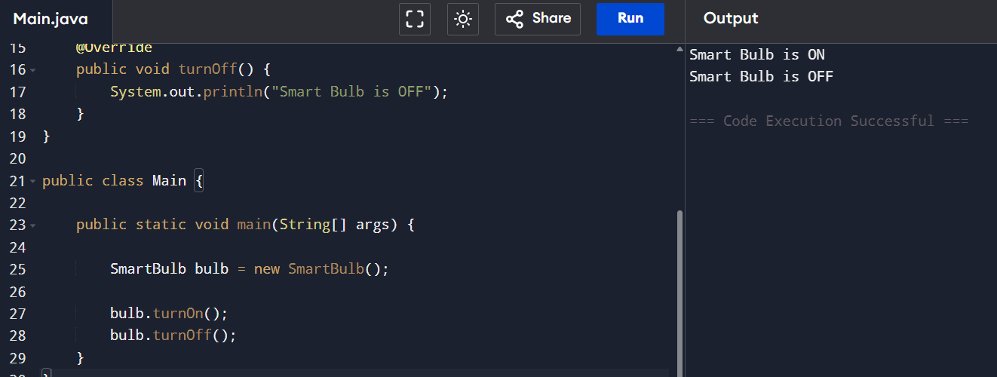

Question 3: Can one device implement multiple interfaces? Give an example.
Answer
Yes.
A class can implement multiple interfaces.
Example:
interface SmartDevice {
void turnOn();
void turnOff();
}

interface WiFiEnabled {
void connectWiFi();
}
class SmartAC implements SmartDevice, WiFiEnabled {
public void turnOn() {
System.out.println("AC ON");
}
public void turnOff() {
System.out.println("AC OFF");
}
public void connectWiFi() {
System.out.println("WiFi Connected");
}
}
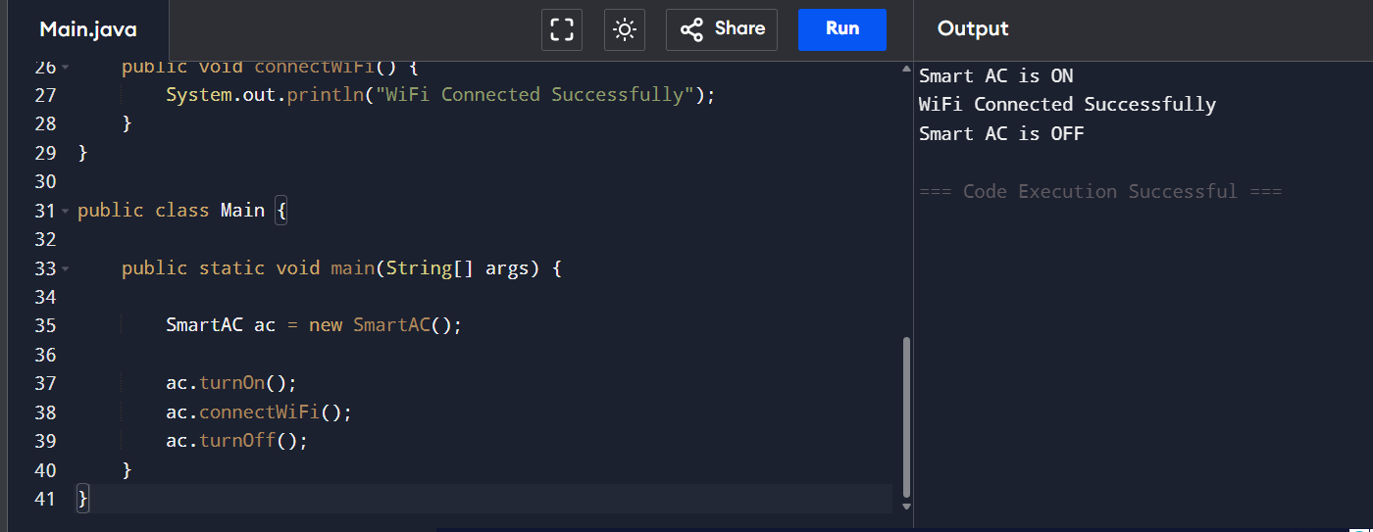

Question 4: Why is an interface better than creating a common base class in this scenario?
Answer
An interface is better because:
- It promotes loose coupling, allowing devices to be independent of one another.
- It supports multiple interface implementation, enabling a device to have several capabilities (such as SmartDevice and WiFiEnabled).
- It allows easy integration of third-party devices without modifying existing classes.
- It focuses on defining common behavior rather than forcing a shared implementation.
- It improves the flexibility, scalability, and maintainability of the smart home application.

Conclusion
These scenarios demonstrate the core Object-Oriented Programming concepts in Java:
- Single Inheritance – Enables a child class to inherit features from one parent class.
- Multilevel Inheritance – Allows a class to inherit through multiple levels, promoting code reuse.
- Hierarchical Inheritance – Multiple child classes share common functionality from one parent class.
- Compile-Time Polymorphism – Achieved using method overloading, where the compiler selects the appropriate method.
- Runtime Polymorphism – Achieved using method overriding, where the JVM selects the method based on the actual object.
- Interface – Defines common behaviors while allowing different classes to provide their own implementations, making applications flexible and extensible.

